Report

Laboratory Work 7

Dmitry Ladutsko

August 15, 2022

# 

# 1. Prerequisites Task Information

## 1.1. Passwords Index

|  |  |  |
| --- | --- | --- |
| Password Group | Login Name | Password |
| Operation System | root | “rootadmin” |
|  | oracle | “oracleadmin” |
|  |  |  |
| Oracle System | sys | “sysadmin” |
|  | system | “sysadmin” |
|  |  |  |
| Oracle Users | All DB users | “%PWD%” |
|  |  |  |
|  |  |  |

## 1.2. Folder Paths Index

|  |  |  |
| --- | --- | --- |
| Path Group | Path Description | Path |
| Operation System | Oracle RDBMS – BIN | /oracle/app/oracle |
|  | Oracle Inventory | /oracle/app/oraInventory |
|  | Oracle Database Storage | /oracle/oradata |
|  | Oracle Install Directory | /oracle/install |
| Oracle | ORACLE_BASE | /oracle/app/oracle |
|  | ORACLE_HOME | $ORACLE_BASE/product/11.2 |
|  |  |  |
| FTP | ftp Incoming Folder | **/ftp/incoming** |
|  |  |  |
|  |  |  |

# 2. Materialized Views- Basic

## 2.1. Task 01: Create Materialized Views - ON DEMAND

**The Main Task** is to create Materialized Views, which will refresh ON DEMAND. You should use SQL script that was prepared by you on LabWork 02 – Report Layout Monthly.

**Required points:**

* Use Standard CREATE MATERIALIZED VIEW CLAUSE
* Use DBMS_MVIEW package to run refresh MView.



***Note.*** Before creating Materialized Views with SA_* user, we firstly need to grant it privileges. Now let’ create Mat. View as monthly report from Laboratory Work 2:

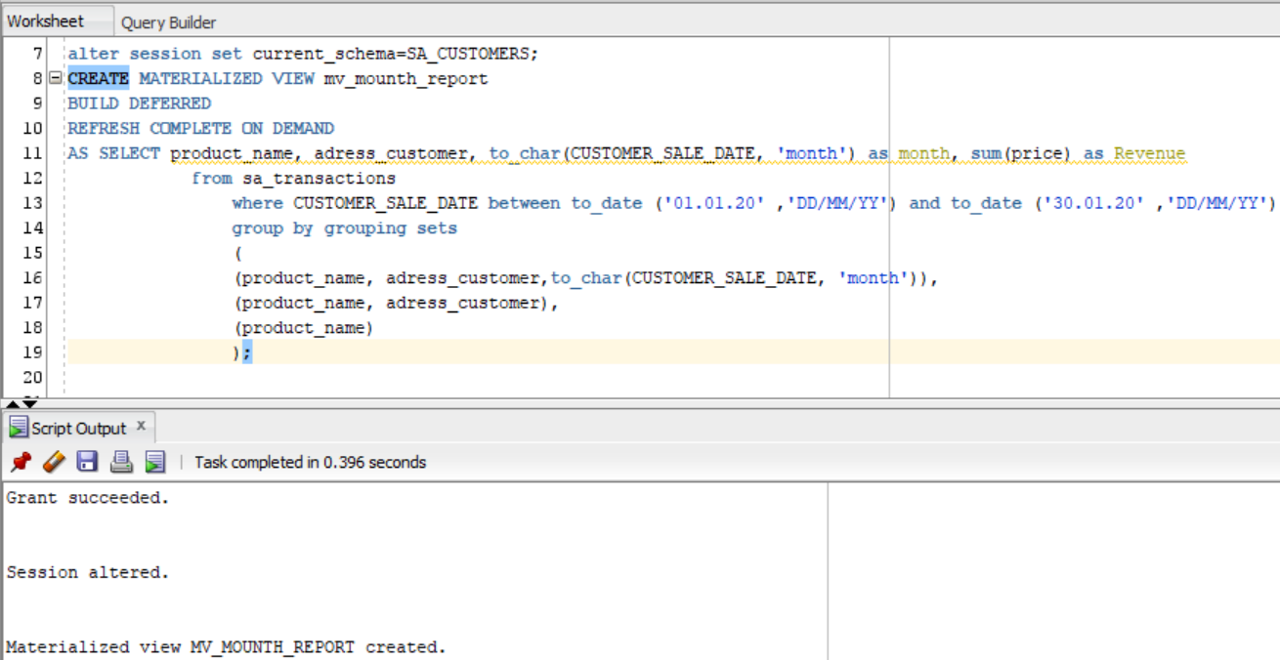

And create **Procedure** to refresh mat. View using **DBMS_MVIEW.REFRESH**

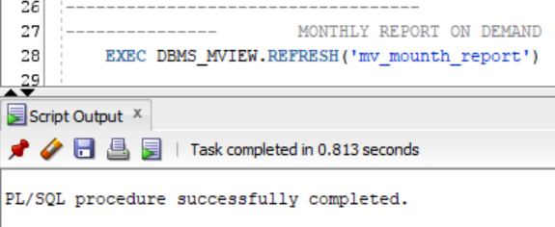

**Results:**

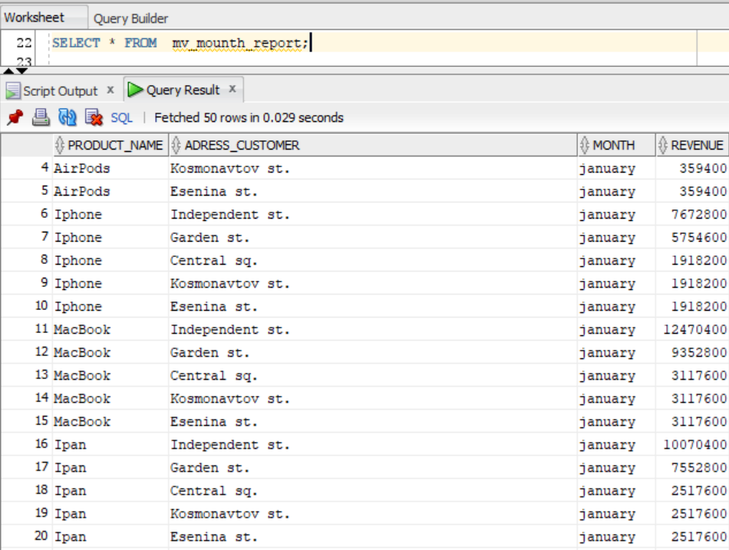

**Task Results:**

Create required objects:

* Put objects script to Git.
* Prepare Document with Screenshot of Tests Data

Prepare Document with Screenshot of Refreshing MView script

## 2.2. Task 02: Create Materialized Views - ON COMMIT

**The Main Task** is to create Materialized Views, which will refresh ON COMMIT. You should use SQL script that was prepared by you on LabWork 02 – Report Layout DAILY.

**Required points:**

* Use Standard CREATE MATERIALIZED VIEW CLAUSE
* Tests ON COMMIT REFRESH.

***Note.*** Let’s create another Materialized View Refresh on commit using daily report from Laboratory Work 2 (to see the revenue for specified day).

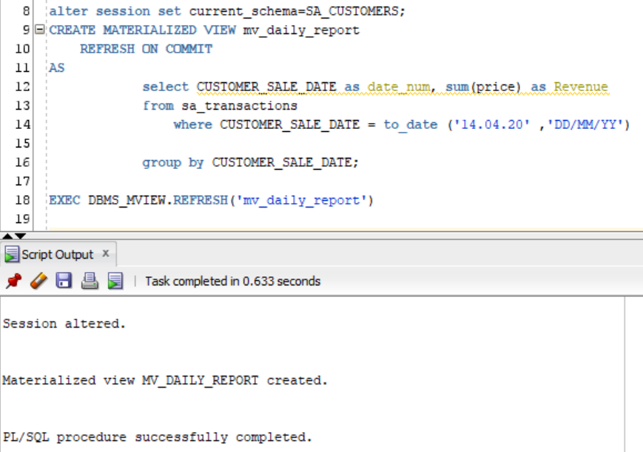

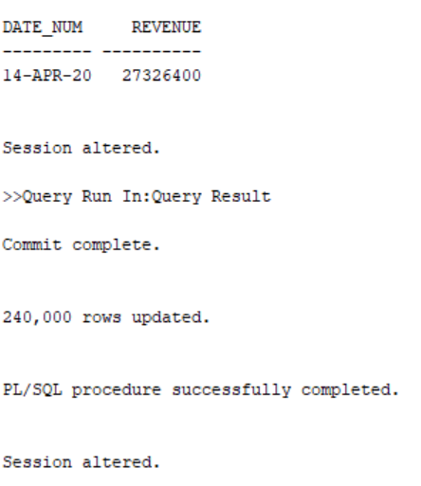

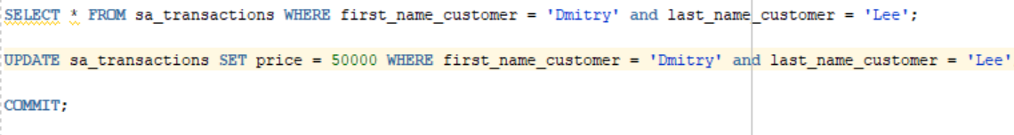

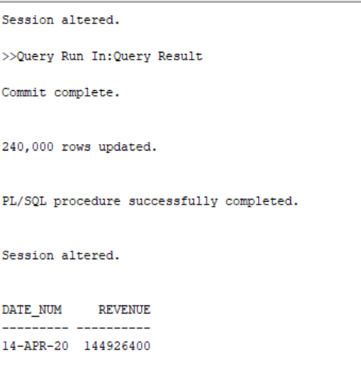

***Note.*** We can see that before we commit transaction nothing have changed in Mat. View.

**Task Results:**

Create required objects:

* Put objects script to Git.
* Prepare Document with Screenshot of Tests Data
* Prepare Document with Screenshot of Refreshing MView script

# 3. Materialized Views- Model Clause

## 3.1. Task 03: Create Materialized Views - Refreshing at definitive Time moment

**The Main Task** is to create Materialized Views, which will refresh definitive Time moment. You should use Model SQL script that was prepared by you on LabWork 05 – Report Layout Monthly.

**Required points:**

* Use Standard CREATE MATERIALIZED VIEW CLAUSE
* Test Refreshing at definitive Time moment.

**Task Results:**

Create required objects:

* Put objects script to Git.
* Prepare Document with Screenshot of Tests Data
* Prepare Document with Screenshot of Refreshing MView scripts

**Laboratory Work Summary**

**At this Laboratory Work** we practised different typed **Materialized Views** from previously created **Reports**. Saw the difference between them and their special features. Tested received results …